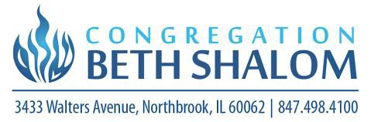

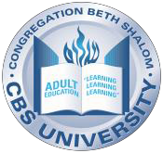

CBS University Class Offerings |Fall 2025

Israel in Depth (In Person & Via Zoom)
Instructor: Carl Schrag
Date: Sunday 9/14,
Time: 10:00 – 11:30 am
Fee: Free for CBS members; $50 for non-member friends of CBS

Returning! Teaching Tanakh (In Person & Via Zoom)
Instructor: Rabbi David Chapman or Cantor Steven Stoehr
Dates: Mondays 10/27, 11/3, 11/10, 11/17, 12/1, 12/8, 12/15
Time: 11:30 am – 12:30 pm
Fee: Free for CBS members; $50 for non-member friends of CBS

Jewish News of the World (In Person & Via Zoom)
Instructor: Carl Schrag
Dates: Tuesdays 9/9, 9/6, 10/21, 10/21,10//28, 11/4,11/11,11/18
12/2, 12/9, 12/16
Time: 10:30 – 11:30 am
Fee: Free for CBS members; $50 for non-member friends of CBS
Returning! Elul the Art of Starting Again
Instructor: Rabbi David Chapman
Dates: Tuesdays 9/9, 9/16
Time: 4:30 – 5:30 pm
Fee: Free for CBS members; $20 for non-member friends of CBS

New Class! Ctrl+Alt+Del (ight): Rebooting Your Jewish Experience (In Person Only limited space)
Instructor: Rabbi Jacki Honig
Dates: Tuesdays 10/28, 11/3, 11/10, 11/17, 12/1, 12/8, 12/15
Time: 6:30 pm – 7:30 pm
Fee: Free for CBS members; $50 for non-member friends of CBS

New Class! Parshat HaShavuah
Instructor: Rabbi Jacki Honig
Dates: Wednesdays 11/19,12/3,12/10,12/17
Time: 10:00 – 11:00 am
Fee: Free for CBS members; $50 for non-member friends of CBS
Tai Chi Sponsored by HAZAK (Zoom Only)
Ready to register? Go to
https://tinyurl.com/classregCBSU
New classes will be added…check the CBS website often!
Instructor: Allison Deputy, Moon Willow Tai Chi
Date: Thursdays 9/4, 9/11, 9/18, 9/25, 10/9, 10/16, 10/23, 10/30, 11/6, 11/13,
11/20, 12/4, 12/11, 12/18
Time: 9:30 – 10:15 am
Fee: Free for CBS members; donation suggested for non-member friends of CBS
New Class! Beginning Hebrew (In Person Only)
Instructor: Susan Stoehr
Date: Thursdays 9/4, 9/11, 9/18, 9/25, 10/9, 10/16, 10/23, 10/30, 11/6, 11/13,
11/20, 12/4, 12/11, 12/18
Time: 10:30 – 11:00 pm
Fee: Free for CBS members; $100 for non-member friends of CBS

Continuing! Hebrew (In Person Only)
Instructor: Susan Stoehr
Date: Thursdays 9/4, 9/11, 9/18, 9/25, 10/9, 10/16, 10/23, 10/30, 11/6, 11/13,
11/20, 12/4, 12/11, 12/18
Time: 11:00 – 12:00 pm
Fee: Free for CBS members; $100 for non-member friends of CBS

:
For questions about these or any other CBS University classes or programs, email ATaxer@BethShalomNB.org

S


