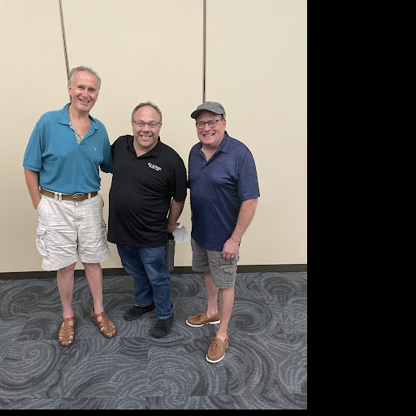

Photo left to right: Howard Jacob, Neil Rosengard, Randy Samborn
Group members not in the photo: Howard Freidin, Larry Levin, Scott Rogoff and Dan Sher

