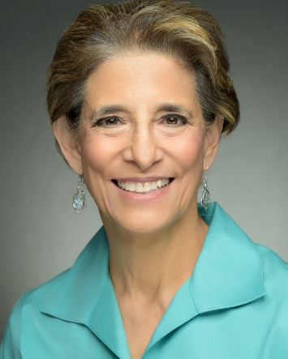

Rabbi Anita Silvert is an Independent community lifecycle officiant, and a long-time adult Jewish educator Previously, she was Director of Enrollment for Spertus Institute, National Director of Outreach for Chai Mitzvah, and an Adult Educator at JCC Chicago. Silvert was a founding volunteer for Limmud Chicago, sits on the North American Limmud Board, and has taught at Limmuds all over the country, and the UK. Silvert is a certified Bibliodramatist, using role-playing and improvisation to explore sacred text. She has been a residential scholar at congregations, women’s organizations, and retreats. She was the Theater Director at OSRUI Camp. Silvert received her BA in Voice from University of Iowa, and her MA in Jewish Education from Spertus. She lives in Northbrook with her husband Don, and whichever of her adult children that are around.

